**Exercise 4: Variables and Names**

When I wrote this program the first time I had a mistake, and Ruby told me about it like this:

There are 100 cars available.

There are only 30 drivers available.

There will be 70 empty cars today.

ex4.rb:14: undefined local variable or method `carpool_capacity' for

main:Object (NameError)

Explain this error in your own words. Make sure you use line numbers and explain why.

**The carpool_capacity is not defined in the program. If we are declared the variable carpool_capacity, then shouldn’t get error.**

1. I used 4.0 for space_in_a_car, but is that necessary? What happens if it's just 4?

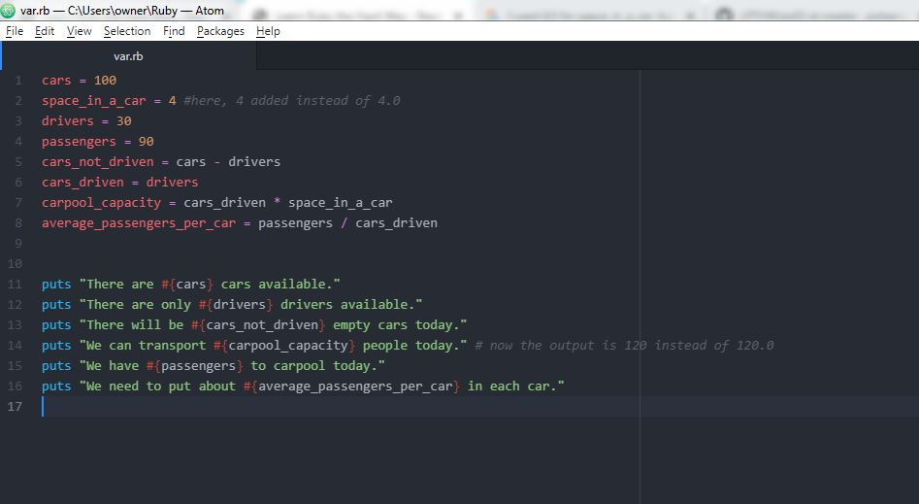

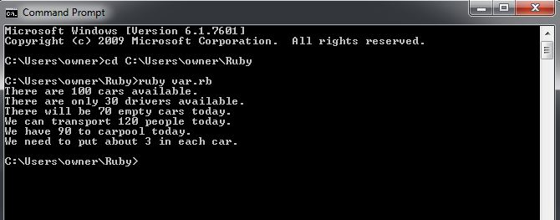

1. Remember that 4.0 is a floating point number. It's just a number with a decimal point, and you need 4.0 instead of just 4 so that it is floating point.

**Ok**

1. Write comments above each of the variable assignments

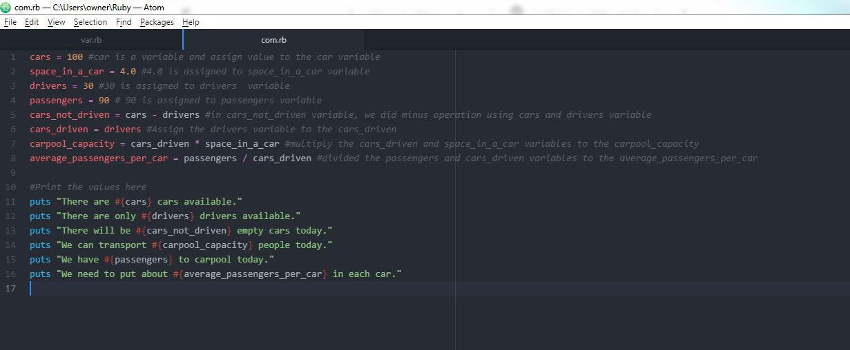

1. Make sure you know what = is called (equals) and that its purpose is to give data (numbers, strings, etc.) names (cars_driven, passengers). **OK**
2. Remember that _ is an underscore character. **OK**
3. Try running ruby from the Terminal as a calculator like you did before, and use variable names to do your calculations. Popular variable names are also i, x, and j.